Press release
____________

Tarkett North America

El Alma Custom Hospitality Carpet Collection From Tarkett Embraces Handcrafted Heritage

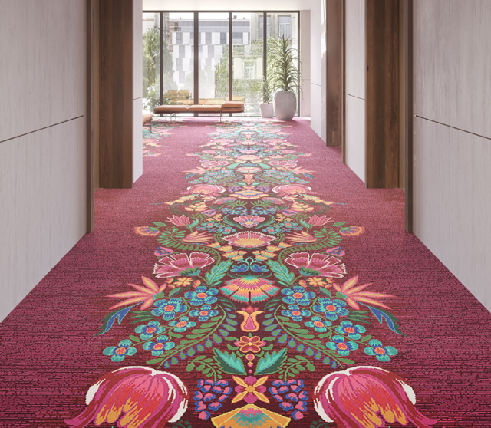
SOLON, OH, December 4, 2020 Tarkett Hospitality, a worldwide leader in hospitality flooring, is introducing a new custom carpet collection that draws inspiration from the history and heritage of handcrafted textiles from Mexico and Central America. Available in ten unique yet interconnected patterns, the new El Alma collection draws inspiration from traditional motifs and embroidery visuals developed by Latin American cultures, spotlighting the artisans and communities who have long kept these crafts alive.

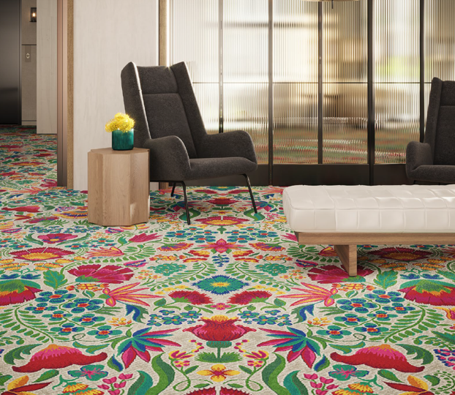
“The artisanal traditions passed down through generations within these diverse cultures have always been and continue to be a driving force of craft and industry in the world, including textiles and floorcoverings,” said Amy Jaekel, creative director, Tarkett Hospitality. “With vibrant beauty and diversity, El Alma connects today’s hospitality spaces to the soul of textile and carpet craftsmanship.”
The new collection celebrates a global influence on design and gives hospitality designers a striking option for creating memorable guest experiences. Each pattern in the El Alma collection has a fully customizable palette, the most elaborate of which features 14 colors. The collection also features a variety of constructions to meet the needs of different spaces within the hospitality environment. Five of the collection’s 10 patterns are designed as Axminster, while the others are machine-tufted to offer a variety of construction options. To further ensure the right solution for any space, Tarkett is able to engineer any of the styles to meet a given budget and project requirements. And the company’s global footprint makes it easy to carry a consistent brand vision throughout the world.
Designs for the collection are made using the company’s 80% wool yarn, which has been third-party tested and proven to provide greater appearance retention, stronger resilience to
crushing and an overall reduction in life-cycle costs. In addition, wool fiber is naturally non-allergenic, flame-retardant and repellant of water and stains.
Tarkett Hospitality’s portfolio of flooring solutions includes Axminster woven carpet, tufted broadloom carpet, LVT, rubber tile and wall base, to name a few. Whether by combining one of the company’s running-line products and accessories in new and unexpected ways, or customizing one of its patterns, Tarkett’s portfolio of hospitality products offers a blend of industrial innovation and artful craftsmanship, lasting performance and beautiful aesthetic. For more information about Tarkett and the company’s comprehensive range of hospitality flooring solutions and accessories, visit www.tarketthospitality.com.
###
About Tarkett
With a history of 140 years, Tarkett is a worldwide leader in innovative flooring and sports surface solutions, with net sales of €3 billion in 2019. Offering a wide range of products including vinyl, linoleum, rubber, carpet, wood, laminate, artificial turf and athletics tracks, the Group serves customers in over 100 countries across the globe. Tarkett has 12,500 employees and 33 industrial sites, and sells 1.3 million square meters of flooring every day, for hospitals, schools, housing, hotels, offices, stores and sports fields. Committed to change the game with circular economy, the Group has implemented an eco-innovation strategy based on Cradle to Cradle® principles, with the ultimate goal of contributing to people’s health and wellbeing, and preserving natural capital. Tarkett is listed on Euronext Paris (compartment B, ISIN: FR0004188670, ticker: TKTT) and is included in the following indices: SBF 120 and CAC Mid 60. www.tarkett.com

Tarkett North America Media Contact

Ryan Heath
Miller Brooks

(317) 873-8100
ryan@millerbrooks.com

