Press release

____________

Tarkett North America

Tarkett at HD Expo: May 15-17, 2019

Creating Great Spaces, One Surface at a Time

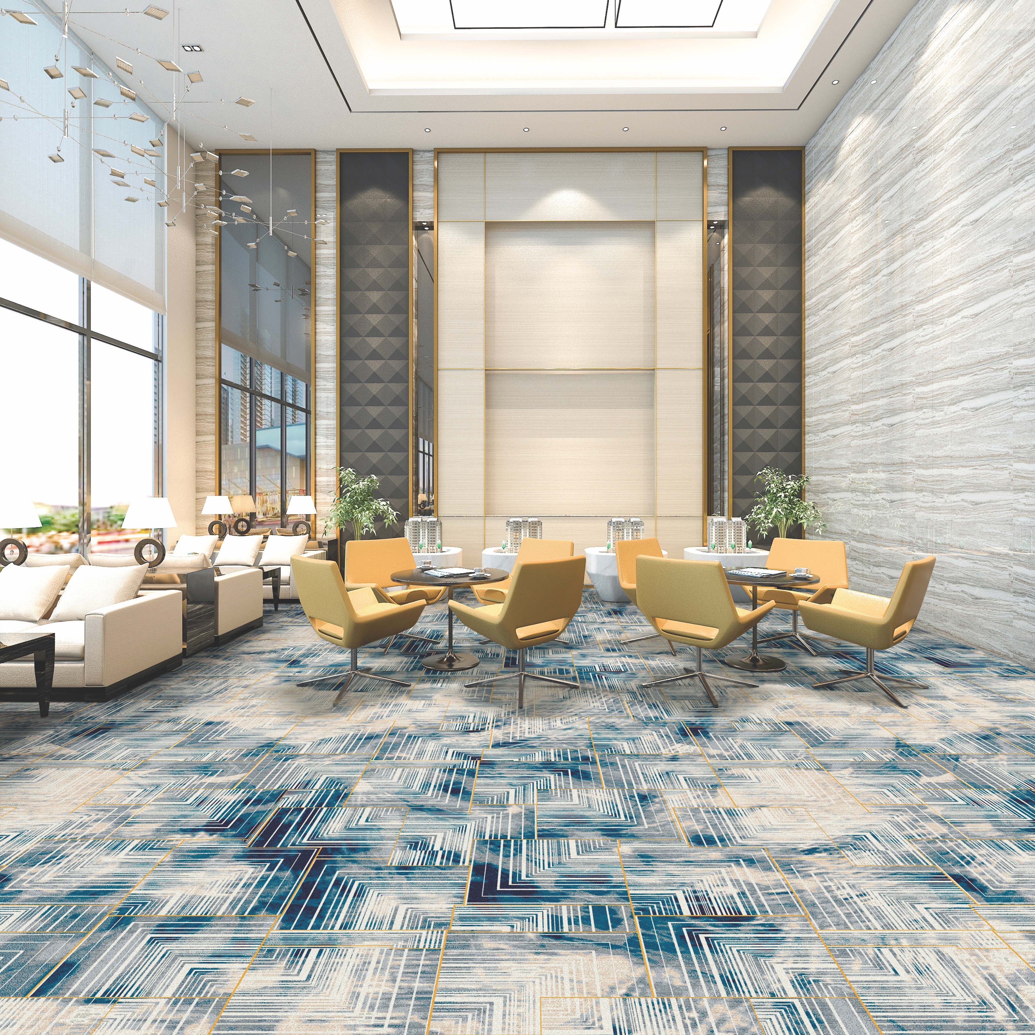

**SOLON, OHIO, May 15, 2019 —** [Tarkett](http://tarkettna.com/), a worldwide leader in innovative and sustainable flooring and sports surface solutions, will showcase Tarkett’s expertise in design and innovation across multiple flooring materials at HD Expo in May 2019. HD Expo 2019 marks the first hospitality trade show to showcase all of Tarkett’s acquired brands, such as Lexmark, under one brand. The company’s best-in-class flooring Solution SPECtrum™ helps create great spaces – one surface at a time.

To celebrate the new brand, Tarkett is a special logo sponsor for this year’s show. Brand logos will be displayed upon attendees’ arrival into the exhibition hall throughout the entire event. The first 500 attendees will also receive Tarkett-branded Camelback water bottles.

The Tarkett exhibit space (#3621) will be transformed into an intriguing display of highly sophisticated design elements with special emphasis on its newest concept collection MergEmerge. The floor design will feature Woven Axminster, Tufted broadloom, custom LVT and Victory LVT. Product wall displays will tie together all of its flooring and accessory solutions for the hospitality market.

In keeping with Tarkett’s reputation as a prolific and innovative global company, a variety of products will be on display and introduced at HD Expo, including:

**NEW CONCEPT COLLECTION:**

**MergEmerge**

MergEmerge, a new custom concept collection, is an experiment in the blending of soft and hard surfaces. The MergEmerge Collection combines pattern and texture unlike anyone has done before. As a visual metaphor for the Tarkett brand, the line represents the creative chemistry that ignites when we come together.

**NEW RUNNING LINES**

**Tufted Collections for Public Spaces and Guest Rooms**

**Available end of May.**

**Classic and Vintage Collection: Embracing Tradition**

Building on the timeless tradition of 19th century European design, Classic and Vintage grace public spaces and guest rooms with welcoming luxury. Every layered detail is exquisitely crafted—from grand scrolls and free-flowing lines to weathered texture and geometric tiling—and brought to life in a regal palette of soft, muted tones.

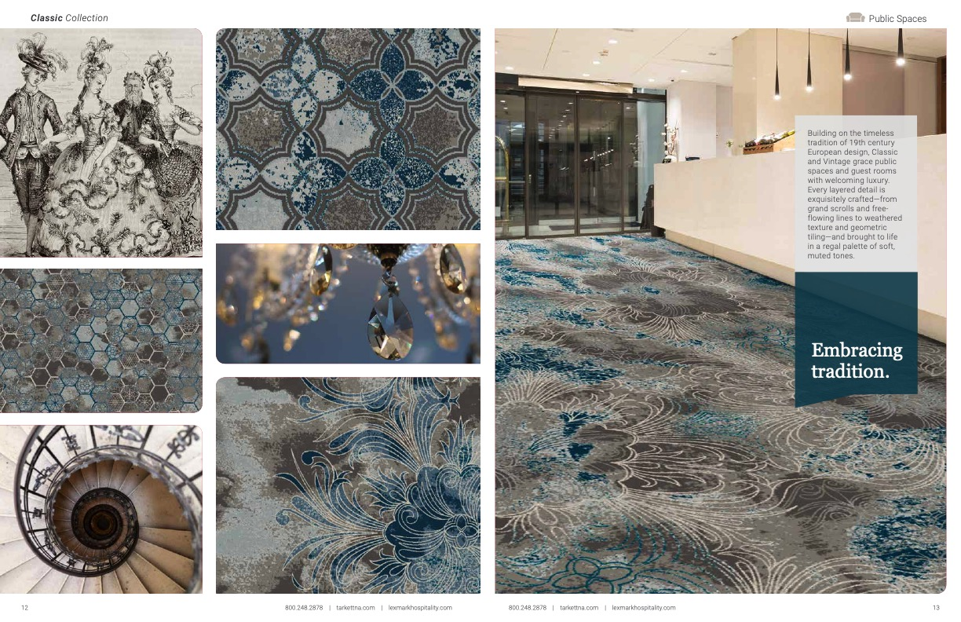

**Kasbah and Nomad Collection: Nomadic Soul**

The Kasbah Collection is defined by free-floating geometrics sparked by a wandering nature and a love for primitive textiles. The soothing neutrals invite travelers with an unrestricted Bohemian feel and a foundation for eclectic accents, curated through a life of adventure. Kasbah’s fractured lines evoke immediate curiosity for this new place, while Nomad softens guest rooms with dancing repetition.

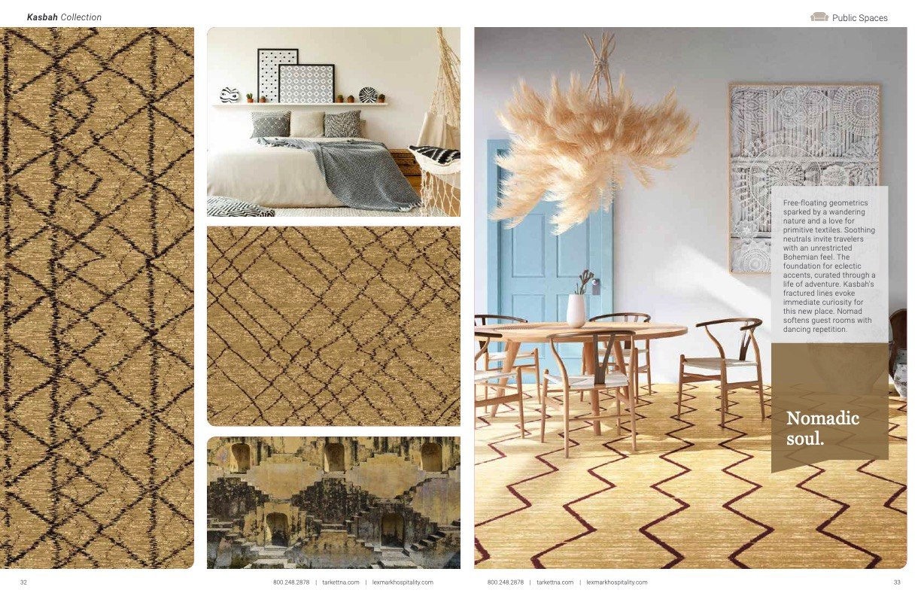

**Mod and Atomic Collection: Funky, Fresh & Futuristic**

Inspired by the bold shapes and saturated colors of mid-century modern design, Mod fills public spaces with a contagious energy and optimism. In guest rooms, Atomic combines linear sensibility with intersecting curves, bringing playful movement and a 1950s feel. Clean lines. Fresh translations. Playful palettes. A celebration of the modern age.

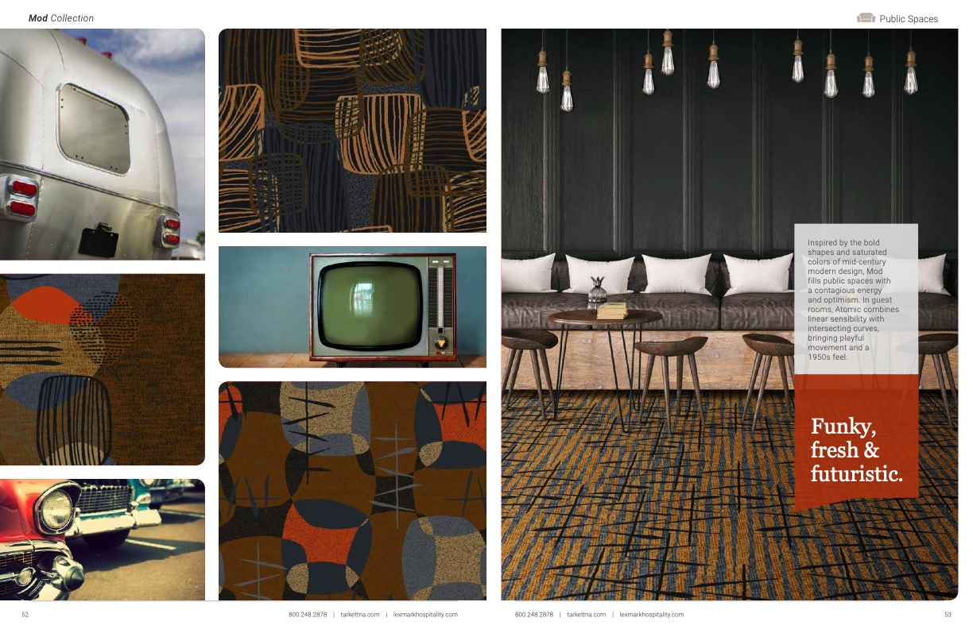

**Surf and Seagrass Collection: Explore the Shoreline**

From the stillness of a small lake to the crashing of ocean waves, water has always provided healing energy. Surf and Seagrass are inspired by sandy shores and dancing tides, bringing the therapeutic rejuvenation of coastal living to interior spaces.

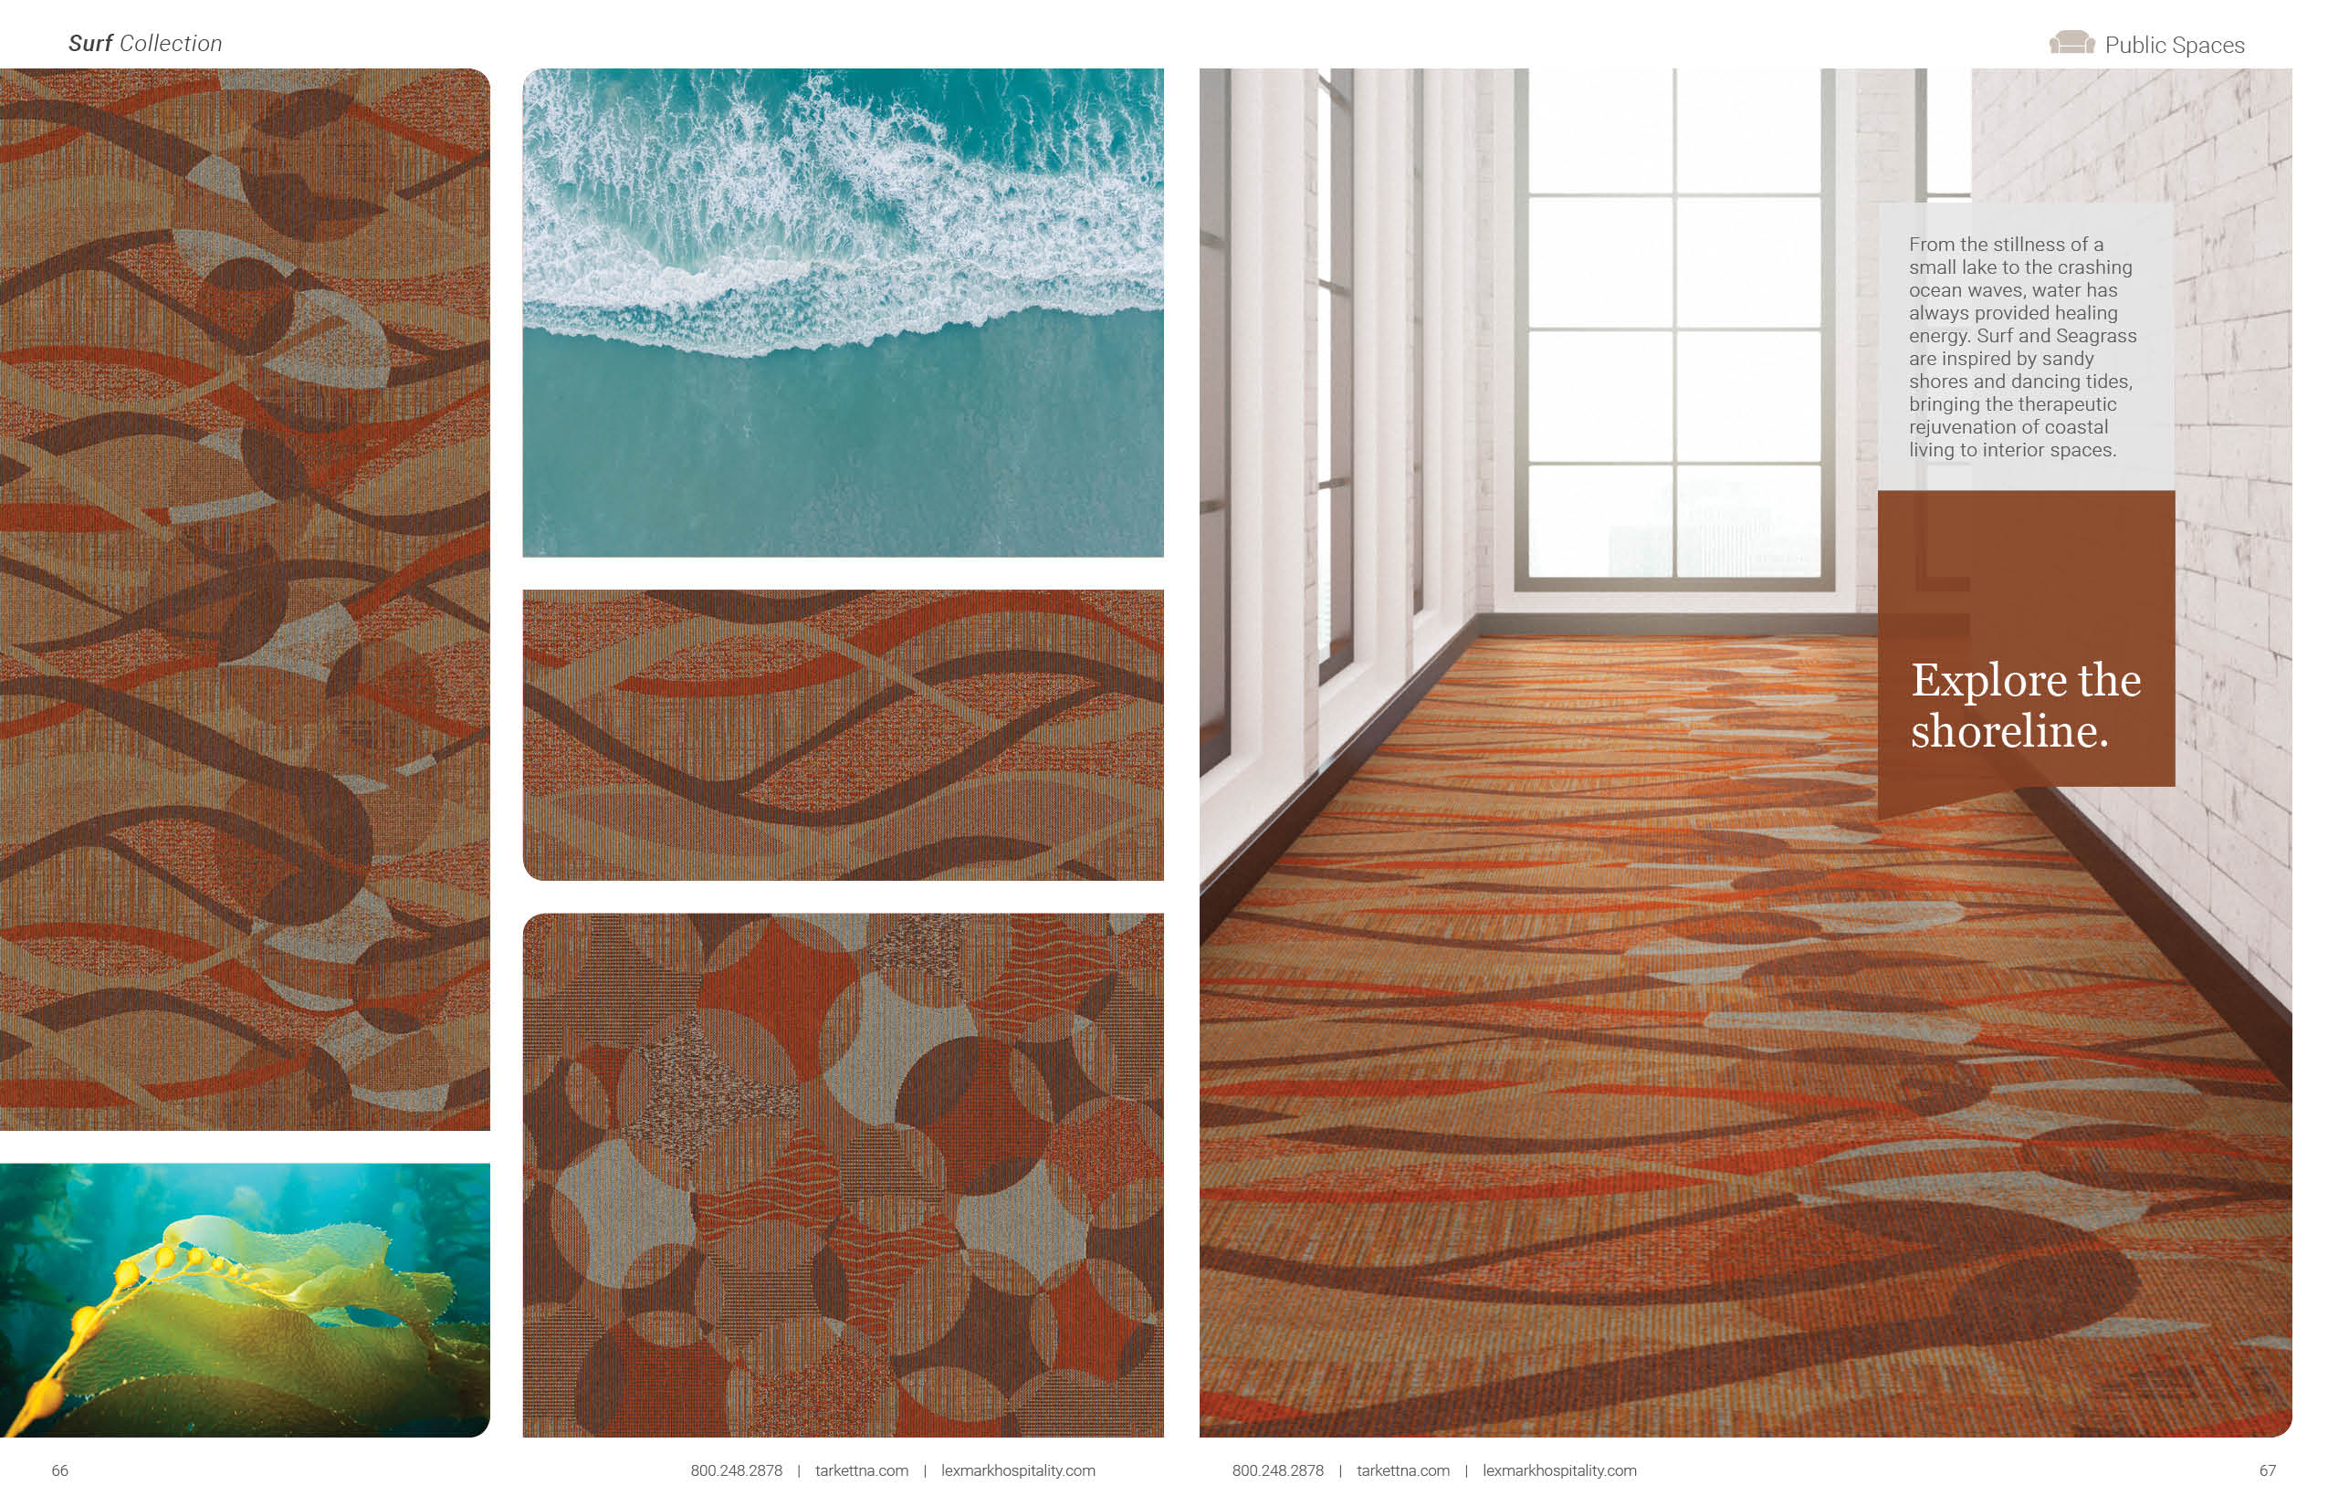

**Terra and Tellus Collection: Rock Solid**

The earth holds a record of the passing of time. Billions of years of memories, permanently etched into its surface. Terra and Tellus celebrate the profound brilliance of our natural surroundings—the unfailing strength, free-flowing color and weathered texture of each rock formation. And the beauty that lives in their enduring presence.

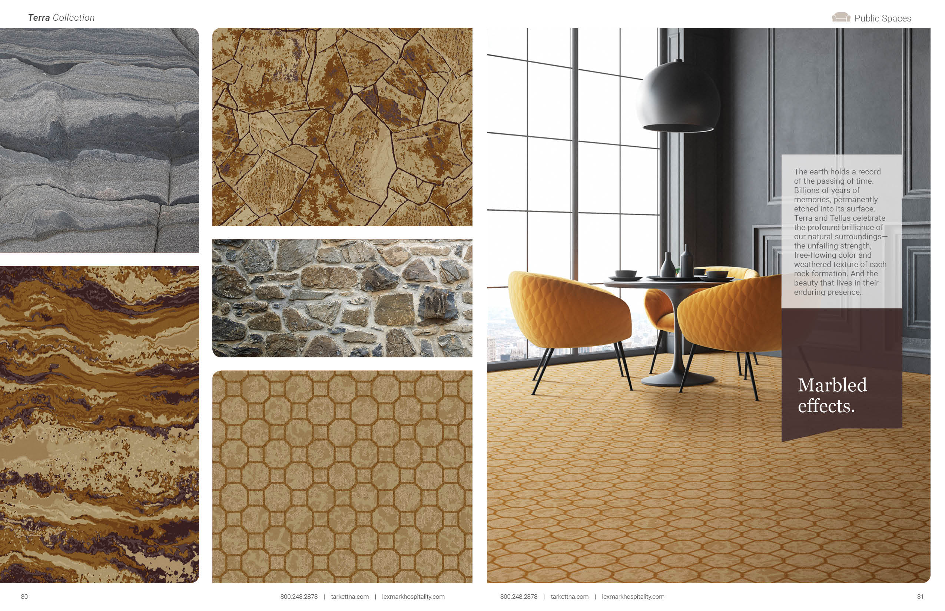

**SPECIAL EVENTS**

**Cocktail Reception:** In the booth, Wednesday and Thursday, May 16 & 17, 3:30-5pm

**Party by the Pool Sponsorship:** Party by the Pool at Drai’s, The Cromwell. Thursday, May 17 from 6:30-8:30pm. Invitation only.

More information about all of Tarkett’s products can be found at www.tarkettna.com. High-res images available upon request.

###

**About Tarkett**

With net sales of more than €2.8 billion in 2017, Tarkett is a worldwide leader of innovative flooring and sports surface solutions. Offering a wide range of products including vinyl, linoleum, carpet, rubber, wood, laminate, synthetic turf and athletic tracks, the Group serves customers in more than 100 countries worldwide. With approximately 13,000 employees and 34 industrial sites, Tarkett sells 1.3 million square meters of flooring every day, for hospitals, schools, housing, hotels, offices, stores and sports fields. Committed to “Doing Good. Together,” the Group has implemented an eco-innovation strategy based on Cradle to Cradle® principles and promotes circular economy, with the ultimate goal of contributing to people’s health and well-being, and preserving the natural capital. Tarkett is listed on Euronext Paris (compartment A, ISIN: FR0004188670, ticker TKTT) and is included in the following indices: SBF 120, CAC Mid 60. [www.tarkett.com](http://www.tarkett.com).

**Tarkett North America Media Contact**

Christie Boyle  
Chrysanthemum Partners

646-342-2571  
cb@chrysanthemumpartners.com