Press release
____________

Tarkett North America

Tarkett Introduces iD Latitude™

A carbon neutral LVT flooring with unmatched durability.
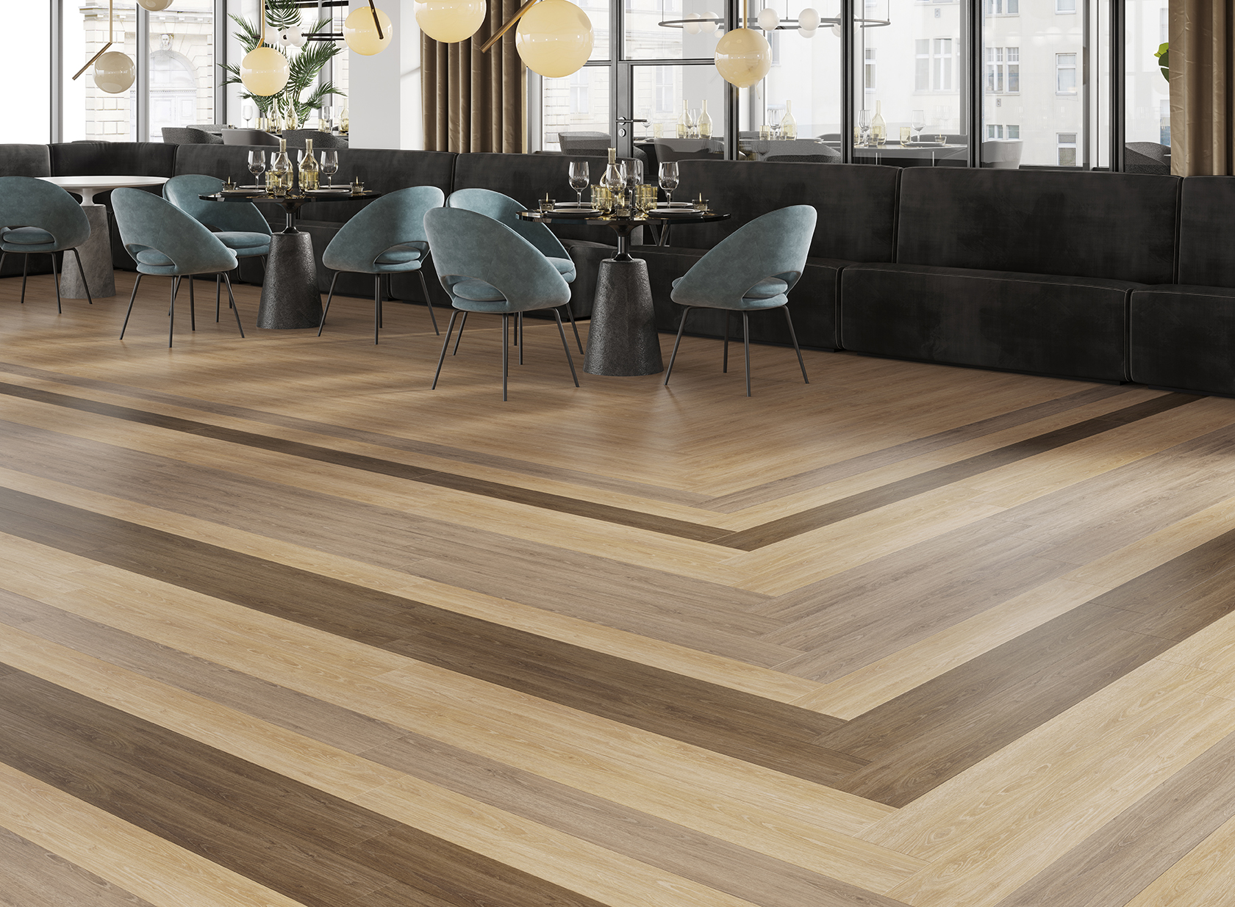
SOLON, OHIO, NOVEMBER 7, 2019 — Tarkett, a worldwide leader in innovative and sustainable flooring and sports surface solutions, introduces iD Latitude™ LVT, a carbon neutral flooring that combines great design, lasting performance and practical affordability for almost any interior space.

For the creation of iD Latitude™, Tarkett went searching for the intersection where great design meets practical affordability, and mindful resources meet lasting performance. This pioneering combination of striking visuals and best-in-class Techtonic™ protection is a fully carbon neutral solution—providing an unmatched flooring experience that moves us all forward.

Best-in-Class TECHTONIC™ Protection
iD Latitude is the ideal combination of style and durability. Made with Techtonic advanced polyurethane technology, the collection provides unmatched resistance to scratch, scuff, stain and abrasion. Instead of unnecessary additives that lead to scratch whitening caused by the daily stresses of feet and furniture, Techtonic™ uses a proprietary polymer system—forming a naturally clear, verifiably stronger layer of protection, while its matte finish eliminates distracting glare.

Leading Designs
The full portfolio of visuals includes stylish Woods, Stones and Abstract designs that meet the needs of today’s contemporary interiors. Each one is manufactured in the USA, and designed to ensure quick installation, immediate occupancy, and easy maintenance without special cleaners or procedures.

iD Latitude Woods
Delivering an authentic look of natural wood grain, iD Latitude Woods include soothing cool to cozy warm tones, refreshing light to dramatic dark looks, and a variety of wood grain patterns for complete flexibility. This full suite includes a natural-looking surface for every design aesthetic—from contemporary oak and pine, to traditional cherry and walnut, to the distinctive details of craft maple, hickory and teak.

iD Latitude Stones
Featuring a variety of relevant stone and concrete looks, iD Latitude Stones pair flawlessly with the rest of the collection to provide interesting borders and accents. Offering a combination of proven bestsellers and new, contemporary designs, each pattern includes subtle color and texture shifts that create beauty and movement, just as nature intended.

iD Latitude Abstracts
iD Latitude includes a suite of best-selling Abstract designs that have been specifically colored to work with the rest of the collection—allowing you to mix and match them with wood and stone looks for added visual interest or helpful wayfinding. Add fun and energy to a space with the intense colors found in ColorGrain or amplify depth through a fusion of textures with Stria Marble. With so many options, each space can express a unique element while keeping continuity and flow uninterrupted.

Carbon Neutral
In addition to improving the health and wellness of the space with low TVOCs, iD Latitude is a carbon neutral solution, helping to decrease our carbon footprint, reduce greenhouse gases and reverse the effects of climate change.

Tarkett’s carbon offsets contribute to multiple global projects, including the reforestation of biodiversity hotspots in the Peruvian Amazon. Through our support of the Tambopata National Reserve and the Bahuaja Sonene National Park, nearly 1.5 million acres have been protected and 10,000 acres have been restored, resulting in 4 million tons of CO2 being avoided. By offsetting carbon emissions, Tarkett is addressing the single largest threat to the planet’s health planet and taking action against climate change.

Tarkett North America believes that together, we can make a positive impact on people and the planet. That’s why we’re Doing Good—Together, connecting our sustainability efforts with what customers value and the world needs. It’s an active, living commitment to create a future where people and the planet prosper in balance. Where sustainable flooring solutions don’t just perform, they inspire.

iD Latitude details include:
- Carbon neutral
- FloorScore® certified
- 100% recyclable through the ReStart® reclamation program

Great Spaces. One Surface at a Time.
Tarkett’s new mission is Great Spaces. One Surface at a Time. Through design, the company explores an array of creative surface solutions designed to support positive, productive experiences in any space. With collaboration, Tarkett seeks to bring insight and inspiration, with co-created products and innovations that foster interactive spaces. From a commitment to sustainability, it delivers wellness-minded, environmentally-conscious solutions – all backed by actual data. United under a single brand, Tarkett, the company finds an unprecedented breadth of offering, with all the products needed, all in one place.

The Tarkett Solution SPECtrum™
Tarkett also believes in placing people in the center of every space, so they developed a portfolio of products designed to work together both functionally and aesthetically. The Tarkett Solution SPECtrum™ has an extensive product offering across soft and resilient surfaces and accessories. The brand focuses on proven attributes and strategies to enhance living and working environments, while improving user satisfaction.

More information about all of Tarkett’s products can be found at www.tarkettna.com. High-resolution product images available upon request.
###
About Tarkett
With a history stretching back 135 years, Tarkett is a worldwide leader in innovative flooring and sports surface solutions, with net sales of more than €2.8 billion in 2018. Offering a wide range of products, including vinyl, linoleum, rubber, carpet, wood, laminate, artificial turf and athletic tracks, the Group serves customers in over 100 countries across the globe. Tarkett has 13,000 employees and 36 industrial sites and sells 1.3 million square meters of flooring every day, for hospitals, schools, housing, hotels, offices, stores and sports fields. Committed to "Doing Good—Together," the Group has implemented an eco-innovation strategy that is based on Cradle to Cradle principles and promotes a circular economy, with the ultimate goal of contributing to people's health and wellbeing, and preserving natural capital. Tarkett is listed on Euronext Paris (compartment A, ISIN: FR0004188670, ticker: TKTT) and is included in the following indices: SBF 120 and CAC Mid 60 www.tarkett.com.

Tarkett North America Media Contact

Christie Boyle
Chrysanthemum Partners

646-342-2571
cb@chrysanthemumpartners.com

